Name : Moeurn Puthsitha

Gender : Male

Class : E6

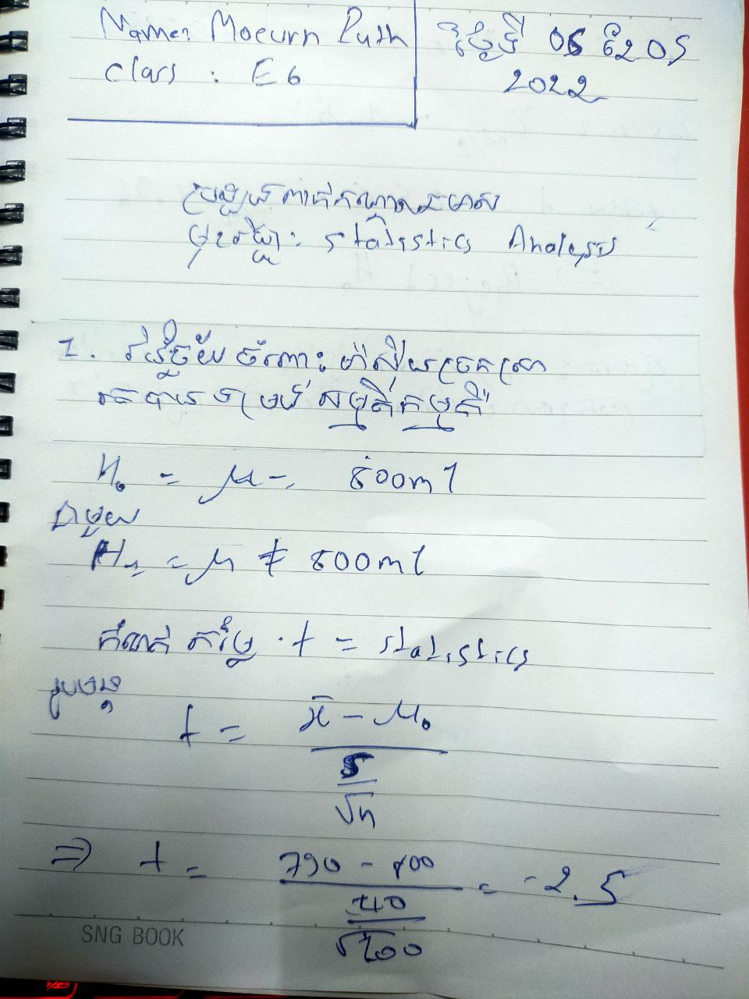

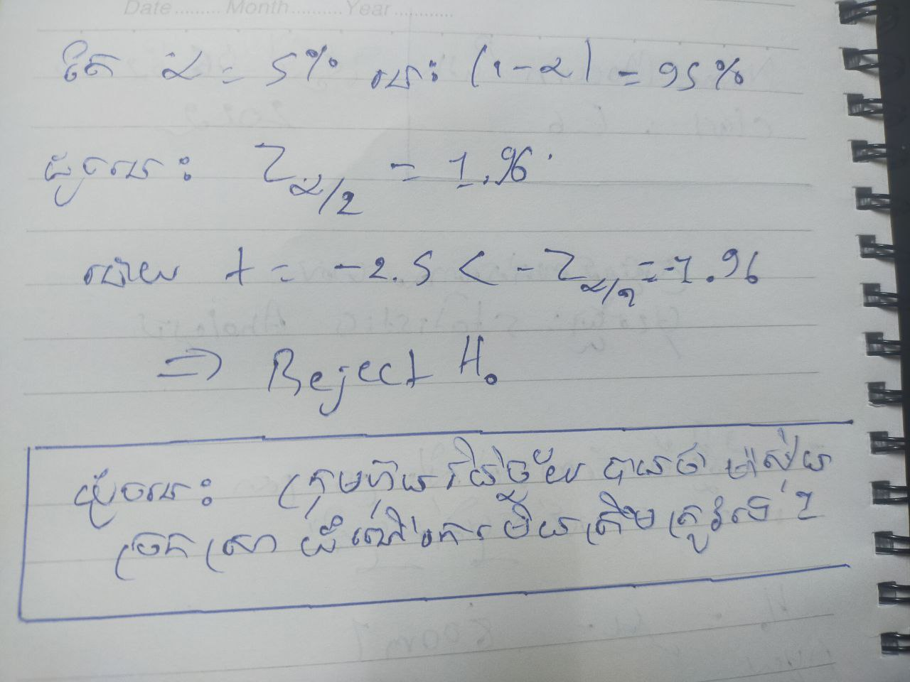

1. Salary before taking scholarship, Salary after taking scholarship. (Test value: 30 0000)

|  |  |  |  |  |
| --- | --- | --- | --- | --- |
| **One-Sample Statistics** | | | | |
|  | N | Mean | Std. Deviation | Std. Error Mean |
| Salary before taking scholarship | 44 | 1717272.7273 | 3191210.57706 | 481093.09596 |
| Salary after taking scholarship | 108 | 1057728.4815 | 512478.49459 | 49313.26613 |

|  |  |  |  |  |  |  |
| --- | --- | --- | --- | --- | --- | --- |
| **One-Sample Test** | | | | | | |
|  | Test Value = 300000 | | | | | |
| t | df | Sig. (2-tailed) | Mean Difference | 95% Confidence Interval of the Difference | |
| Lower | Upper |
| Salary before taking scholarship | 2.946 | 43 | .005 | 1417272.72727 | 447056.0335 | 2387489.4210 |
| Salary after taking scholarship | 15.366 | 107 | .000 | 757728.48148 | 659970.6828 | 855486.2802 |

Before taking scholarship the participants were asked about salary. In average, the participants earned 1717272.7273 out 300000. According to t-test the participants earned not significantly higher salary than an average salary (P-Value = 0.005).

The participants earned 1057728.4815 out 300000, but the participants salary were significantly lower than an average (P-Value = 0.000).

1. Salary after taking salary scholarship, Expected salary(The test value: 40 0000)

|  |  |  |  |  |
| --- | --- | --- | --- | --- |
| **One-Sample Statistics** | | | | |
|  | N | Mean | Std. Deviation | Std. Error Mean |
| Salary after taking scholarship | 108 | 1057728.4815 | 512478.49459 | 49313.26613 |
| Expected salary | 108 | 1667962.9630 | 714757.33972 | 68777.55708 |

|  |  |  |  |  |  |  |
| --- | --- | --- | --- | --- | --- | --- |
| **One-Sample Test** | | | | | | |
|  | Test Value = 400000 | | | | | |
| t | df | Sig. (2-tailed) | Mean Difference | 95% Confidence Interval of the Difference | |
| Lower | Upper |
| Salary after taking scholarship | 13.338 | 107 | .000 | 657728.48148 | 559970.6828 | 755486.2802 |
| Expected salary | 18.436 | 107 | .000 | 1267962.96296 | 1131619.4776 | 1404306.4484 |

Before taking scholarship the participants were asked about salary. In average, the participants earned 1057728.4815 out 400000. According to t-test the participants earned significantly lower score lower than an average salary (P-Value = 0.000).

The participants earned 1667962.9630 out 400000, but the participants score were not significantly higher than an average (P-Value = 0.000).